**How the Sun’s Core Changes the Direction of the Sun’s Magnetic Axes and Maintains the Sun’s Equilibrium, similarly to the Function of the Earth’s Core**

**Yeshayahu Greitzer**

*18 Zeitlin St. Tel Aviv 6495511, Israel*

*Email: shaya-1@zahav.net.il*

**To Cite this Article**

Yeshayahu Greitzer, “How the Sun’s Core Changes the Direction of the Sun’s Magnetic Axes and Maintains the Sun’s Equilibrium, similarly to the Function of the Earth’s Core”, Journal of Science and Technology, Vol. 10, Issue 09, Sep 2025, pp 53-

**Article Info**

Received: 10-July-2025 Revised: 08-Aug-2025 Accepted: 22-Aug-2025 Published: 08-Sep-2025

**Abstract**

*The Sun’s magnetic field shifts every eleven years, from north to south and vice versa. In my view, this occurs due to the movement of the Sun’s core from north to south and vice versa, in order to maintain the Sun’s equilibrium as it revolves around its axis from west to east. In principle, something similar occurs on Earth, as it revolves around its axis from west to east and its core moves alternately north or south, which allows the Earth to maintain its equilibrium, with its magnetic field shifting from north to south and vice versa. The essential difference between the Earth and the Sun in this regard is that the Sun is composed of gaseous material, while the Earth is composed of solid plastic and fluid material. The Sun’s gaseous mass moves and changes rapidly, so the Sun’s core is required to move rapidly in turn and change direction every eleven years in order to maintain the Sun’s equilibrium. Just as the changes that occur on the Earth, such as the movement of the continents or the creation of mountains, are relatively slow, in accordance so too the movement of the Earth’s core is slow and it shifts direction at intervals of from thousands to millions of years, with the time periods between changes being inconsistent.*

***Key Word****:* *The Core of the Sun, The Core of the Earth, Magnetic Solar Cycle, Magnetic Cycle of the Earth*

**I. FOREWORD: GENERAL DESCRIPTION OF THE SUN AND ITS MAGNETIC AXES**

(This description of the Sun, its magnetic field and general characteristics is derived from Google Wikipedia and AI)

The Sun rotates on its axis as it revolves around the galaxy. Its spin has a tilt of 7.25 degrees with respect to the plane of the planets’ orbits. Like the Earth, the Sun rotates around its axis from west to east. The Sun is composed of plasma and gases. The speed of the Sun’s rotation is 25 Earth days at the Equator, 27 Earth days at the temperate zones, and 35 Earth days at the poles. Since the Sun’s Equator rotates faster than the poles, this gives rise to the twisting and deformation of the solar magnetic field over time, which is known as a differential twist.

The Sun has a dynamic and rapidly changing magnetic field—captured under the rubric of the geo-dynamo theory—that is formed by the movement of charged plasma. Unlike the Earth’s, the Sun’s magnetic field is unstable. Its magnetic axis shifts from north to south and vice versa every eleven years; a complete solar cycle takes twenty-two years.

The Sun’s magnetic poles do not always correspond to its geometrical (rotational) poles, and temporary poles are also possible.

The strength of the Sun’s magnetic field changes over the course of a solar cycle, and the Sun’s most intense magnetic activity, which occurs at the peak of the cycle, is related to a reversal of the magnetic field.

The Sun’s composition (by mass) is:

• Hydrogen (H): about 73 percent

• Helium (He): about 25 percent

• Heavier elements (i.e., oxygen, carbon, nitrogen, iron, etc.), which tend to be concentrated in the core: about 2 percent.

With respect to its structure, the Sun is made up of the following (from the inside out):

1. Core – where nuclear fusion takes place; about 20-25 percent of the radius

2. Radiative Zone – up to about 70 percent of the radius

3. Convective Zone – the external area of the Sun’s interior

4. Photosphere – the visible layer

5. Chromosphere – a thin layer above the photosphere

6. Corona – the external halo, seen only during a solar eclipse.

In the course of the Sun’s creation, the solar material collapsed inward under the force of gravity, as happened with the planets (such as the Earth). On the Sun too the heavier materials sank toward the center, the core, because they are denser.

The Sun’s core is where powerful nuclear processes take place—it is small but extremely potent.

A large part of the Sun’s hydrogen has already undergone fusion and been converted into helium, therefore there is less hydrogen and more helium in the core. In the rest of the Sun most of the material is still hydrogen, however, because only the core participates in an active fusion process.

The core accounts for only 0.8 percent of the Sun’s entire volume, even though it contains 34 percent of the Sun’s mass, whereas the Sun’s other parts, of thin density, account for 99.2 percent of its volume but contain 66 percent of its mass.

There is a certain similarity as regards the cause for the magnetic field’s shift from north to south and vice versa, on Earth and on the Sun, though the composition of these two bodies is essentially different. The Sun is made up mainly of gaseous material, while the Earth is made up of solid material, plastic magma, and fluids. In order to explain our conclusion that nonetheless there is a similarity in the mechanism that prompts the shift of the magnetic axes from north to south and vice versa, in what follows we shall describe how this mechanism operates on Earth to shift the magnetic field from north to south and vice versa, then compare the result to the Sun.

**II. GENERAL DESCRIPTION OF THE CORE’S FUNCTION ON THE EARTH AND THE SHIFT OF THE EARTH’S MAGNETIC NORTH AND SOUTH POLES**

Since the beginning of the Earth’s crystallization, its core has been flexible and there have constantly been changes in its axis of rotation. In relation to the law of isostasy, these are the main reasons for the Earth’s stability and its remaining in the form of a relatively round ball (geoid). As a result of the core’s intermittent fluctuation (the movement of its center of gravity) to the northern and southern parts of the Earth, the Earth’s magnetic field also intermittently shifts from north to south and vice versa. Since the core consists mainly of fluid—viscous material (Jordan, T.H., 1979)—its movement makes possible a constant balancing of the changes and pressures in the geological layers of the Earth’s mantle and crust. The core can be pressured in order to balance these changes on the Earth. It is mainly pressured toward the northern half in the direction of the North Pole, or toward the southern half in the direction of the South Pole, to maintain the equilibrium of the Earth, in accordance with the law of isostasy.

Due to its flexibility, the Earth’s core is able to respond relatively rapidly to the significant changes occurring on top of the Earth’s crust or mantle, opposite the locations that change the general equilibrium in relation to the center of the Earth. Assumedly, the core, which applies pressure alternately in northern and southern directions, constitutes a factor in the equilibrium of the Earth. This phenomenon also causes a change in the Earth’s magnetic field. I assume also that this movement has been ongoing continuously since the Earth was formed and assumed its relatively rounded shape (geoid). Since the direction of the Earth’s rotation is from west to east, perpendicular to the Earth’s axis, presumably the core’s change of location, or a change in the movement of part of the core’s mantle, occurs in order to balance the Earth’s equilibrium, mainly perpendicularly in the direction of the Earth’s rotation, toward the North and South Poles.

Due to different phenomena occurring on the Earth—such as the movement of the continents (plate tectonics) or the formation of mountains, when one plate overlaps another or there is a change in the location of the axis of the Earth’s rotation (Greitzer, Sep. 2020), etc.—this movement of the core north and south is not equal in consecutive time periods. All these phenomena balance out each other in different parts of the Earth’s crust and mantle in accordance with the law of isostasy, but primarily with the help of the core, which due to its sensitivity and flexibility exerts a speedy and efficient influence. My assumption is that the center of the Earth to which the law of isostasy relates is found in the core’s center, opposite the Equator. When the core’s center moves north of the Equator, the magnetic field also shifts north (or in the opposite direction); conversely, when the core’s center moves to the south of the Equator, the magnetic field also shifts south (or in the opposite direction).

When we speak about a shift of the core, what we mean is a shift of the core’s center of gravity, which presumably could also be due to the penetration of the core’s viscous fluid material in a specific direction of the Earth, rather than a general shift of the entire core. In any event, this would affect the Earth’s equilibrium, offsetting all other changes occurring in the Earth’s crust and mantle.

A change in the direction of the Earth’s magnetic field over the course of 5.28 million years since the late Cenozoic period has been studied (Tauxe, 1998). The present writer has found that the time period of the magnetic field’s being oriented in the direction of the present northern axis is roughly equal to the time period when it was oriented in the opposite direction. Thus, for 2.62 million years the magnetic field has been oriented in the direction of the present northern axis, while for the previous 2.66 million years it was oriented in the opposite direction, the direction of the present southern axis (Fig. 1). The relatively small difference between the two time periods apparently stems from a section that was measured arbitrarily but does not accurately represent the beginning of the section measured, which was determined to have begun 5.28 million years ago.

**III. . DISCUSSION: HOW THE SUN’S CORE CAUSES THE SHIFT OF ITS MAGNETIC AXES FROM NORTH TO SOUTH AND VICE VERSA, MAINTAINING THE SUN’S EQUILIBRIUM**

The Sun’s magnetic field changes direction from north to south and vice versa every eleven years. In my view, in principle this shift is similar to the change of direction of the Earth’s magnetic field, albeit it occurs much more rapidly relative to the change on the Earth. The Earth’s magnetic axes do not shift direction at regular intervals, and the time period between changes of direction can extend to thousands and even millions of years.

In my article “Changing the Location of the Earth's Core, the Main Force Operating that Changes the Magnetic Field of the Earth” (Y. Greitzer, 2020), some of which was cited in the previous section, I have maintained that the Earth’s core, with its variable movement north and south (perpendicular to the Earth’s rotation from west to east), also serves to maintain the Earth’s equilibrium. The essential difference between the Sun and the Earth in terms of their structure is that the former is composed of gaseous material, the latter of solid plastic and fluid material. The Earth’s core is composed of solid material, iron, nickel, etc., and its envelope is plastic. The Sun’s core too is made up of relatively heavy elements, such as oxygen, carbon, nitrogen and iron, as opposed to most of the Sun’s volume that is made up of mainly light gaseous material, hydrogen. There is a small amount of hydrogen in the Sun’s core too, and a large amount of helium, as the core is where the nuclear fusion occurs and the hydrogen turns to helium.

The Earth’s core is relatively flexible, helping to maintain the Earth’s equilibrium, but it takes a considerable amount of time for it to move in accordance with the changes occurring on the Earth’s solid and plastic envelope, as explained in the previous section. The Sun, on the other hand, is made up of gases: the movement of the Sun’s gaseous mass, due to the Sun’s rotation around its axis, causes the mass to change shape very quickly, so therefore the Sun’s core too has to move very rapidly to maintain the Sun’s equilibrium and to keep it in a stable spheroid shape. When the Sun’s core moves rapidly alternately north and south, this changes the Sun’s magnetic field from north to south and vice versa every eleven years. On the Earth, contrarily, the changes of direction of the core occur in accordance with the external conditions of the Earth’s envelope, including tectonic motion, mountain formation, etc. As on the Sun, though, the core’s movement from north to south and vice versa also causes a corresponding change of the magnetic axis from north to south and vice versa. On the Sun a hydrostatic equilibrium is maintained, which corresponds to the law of isostasy that holds on the Earth, which determines that at every point upon the Sun’s surface, the radius extending to its center must be of equal weight.

As regards the Sun, it need be noted that it is very important for it to be constantly in equilibrium, therefore in my view it is the core’s task to keep the Sun maximally balanced all the time. The Sun must maintain itself in very precise equilibrium because all of the planets are dependent on it: the possibility of being out of balance, even for a very short time, could trigger problems on the various planets that circle the Sun.

**III. CONCLUSION**

The magnetic field of our Sun shift its axis from north to south and vice versa every eleven years. In my view, in principle this occurs similarly to the change of the Earth’s magnetic field, albeit much more rapidly. Furthermore, on the Earth the magnetic axes don’t change at fixed intervals, and the time period between changes can extend from thousands to millions of years.

The Earth’s core is relatively flexible, helping to maintain the Earth’s equilibrium, and it takes a considerable amount of time for it to move in accordance with the changes occurring on the Earth’s solid and plastic envelope. The Sun, however, is composed of gases, and the change in the gaseous mass, due to the Sun’s rotation around its axis, sparks a very rapid change of form of the gaseous mass, therefore the Sun’s core must move very rapidly in order to maintain the Sun’s equilibrium, and to keep it in the form of a stable sphere. As the Sun’s core moves rapidly alternately north and south, it also causes the Sun’s magnetic field to shift from north to south and vice versa every eleven years.

**IV ACKNOWLEDGEMENT**

I thank Ruvik Daniel for translating the original manuscript in Hebrew to English and for editing it.

**REFERENCES**

1. Buffett, B. A. (2000). Earth's Core and the Geodynamo. Science. 288 (5473): 2007–2012. Bibcode: 2000Sci...288.2007B
2. Greitzer, Y. (July 2020). The Centrifugal Force behind the Movement of Continents, Change in the Axis of the Rotating Earth. Journal of Science and Technology**.** ISSN: 2456-5660Vol 05. Issue 04, July-August 2020 DOI: <https://doi.org/10.46243/jst>. 2020.v5.i4. pp69-80.
3. Greitzer, Y. (September 2020). Gravity of The Sun, The Main Force Operating That Changes The Location of The Earth’s Axis of The Earth’s Mantle And, Accordingly, The Location of The Equator. Journal of Science and Technology, ISSN: 2456-5660 Volume 5, Issue 5, Sep-October 2020. www.jst.org.in DOI: <https://doi.org/10.46243/jst.2020.v5.i5.pp188-191>
4. Greitzer, Y. (October. 2020) Changing the Location of the Earth's Core, the Main Force Operating that Changes the Magnetic Field of the Earths. Journal of Science and Technology ISSN: 2456-5660 Volume 5, Issue 6, Nov- December 2020. www.jst.org.in DOI: https://doi.org/10.46243/jst.2020.v5.i6.pp125-127
5. Herndon, J. M. (1996). Substructure of the Inner Core of the Earth. PNAS. 93 (2): 646–648. Bibcode: 1996PNAS...93..646H. doi:10.1073/pnas.93.2.646. PMC 40105 Freely accessible. PMID 11607625.
6. Jordan, T. H. (1979). Structural Geology of the Earth's Interior. Proceedings of the National Academy of Sciences. 76 (9): 4192–4200. Bibcode: 1979 PNAS. 76.4192J. doi:10.1073/pnas.76.9.4192. PMC 411539 Freely accessible. PMID 16592703.
7. Tauxe, Lisa (1998). Paleomagnetic Principles and Practice. Kluwer. ISBN 978-0-7923-5258-7

. 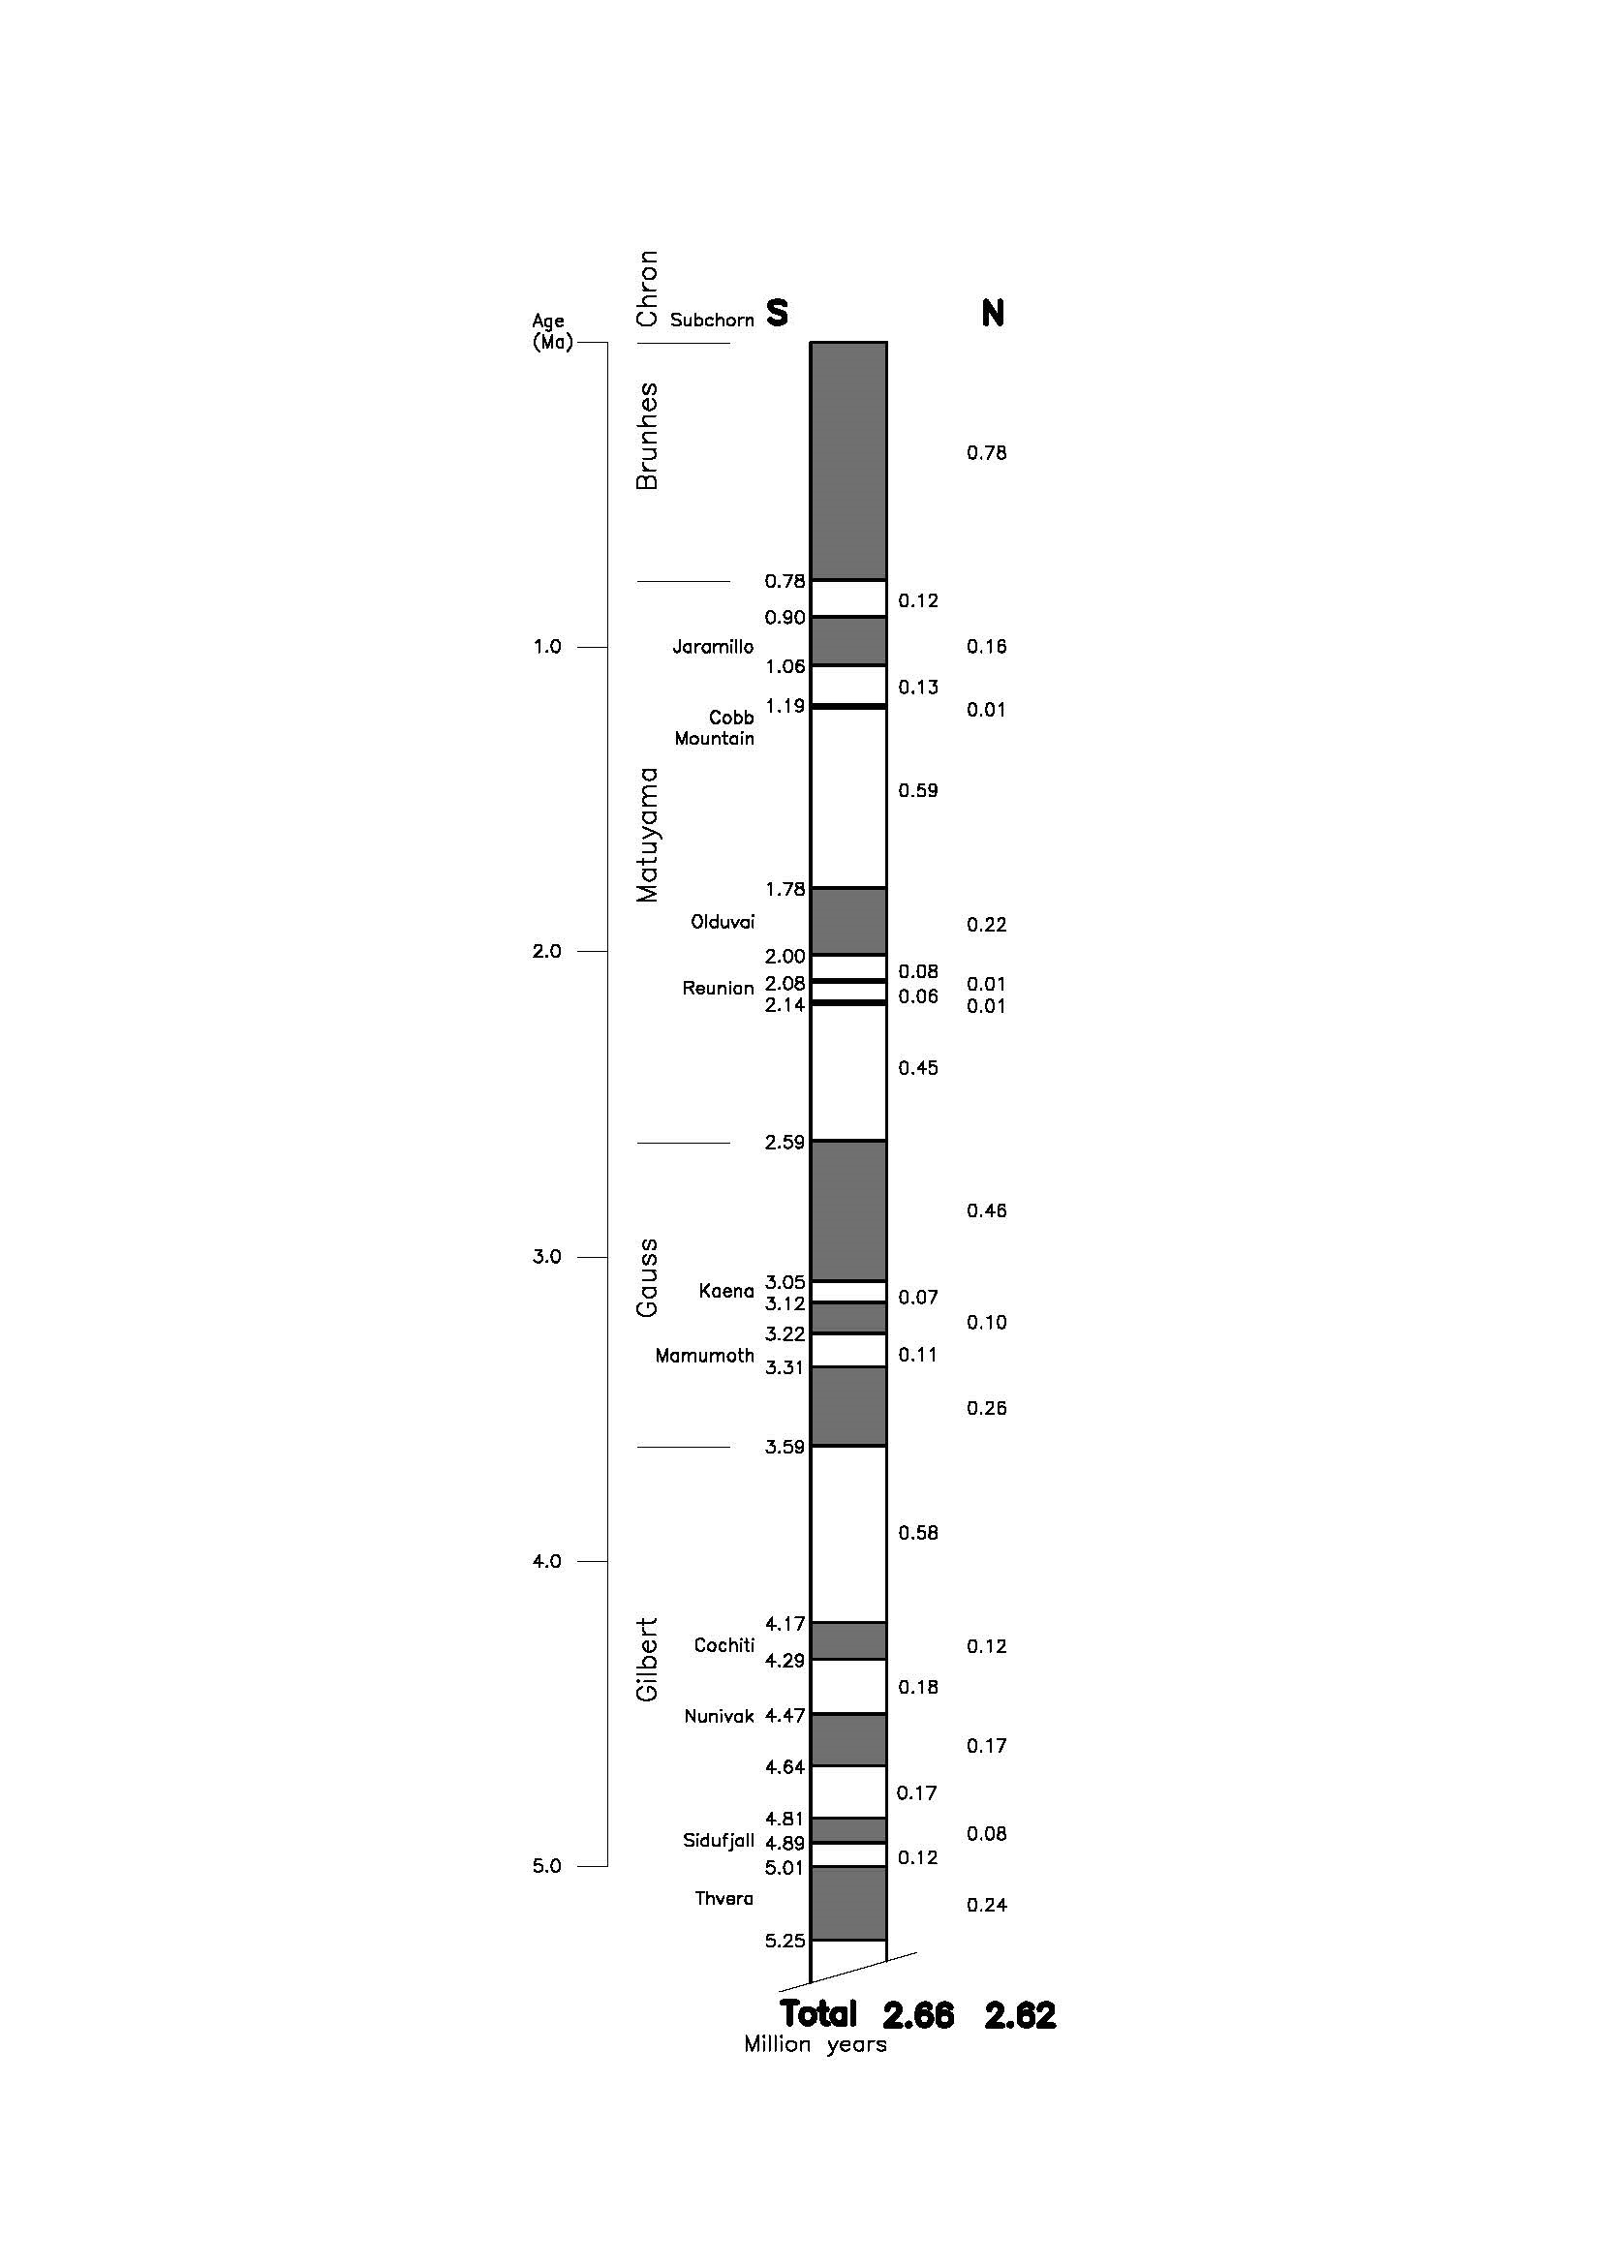

**Figure 1.** Geomagnetic polarity during the late Cenozoic Era in the course of 5.25 million years. Dark areas denote periods where the polarity matches today’s polarity, light areas denote periods where that polarity is reversed. By Y. Greitzer according to Tauxe 1998